Disable students and teacher to create new teams

{<https://docs.microsoft.com/en-us/microsoft-365/solutions/manage-creation-of-groups?view=o365-worldwide>}

Create group type security

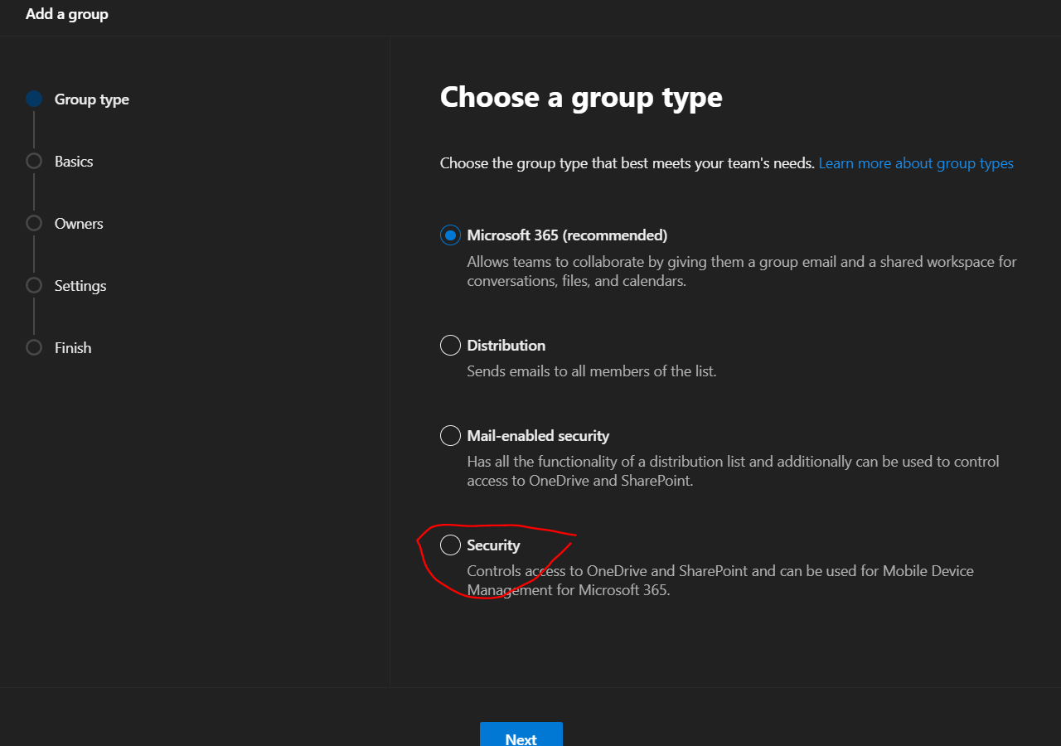

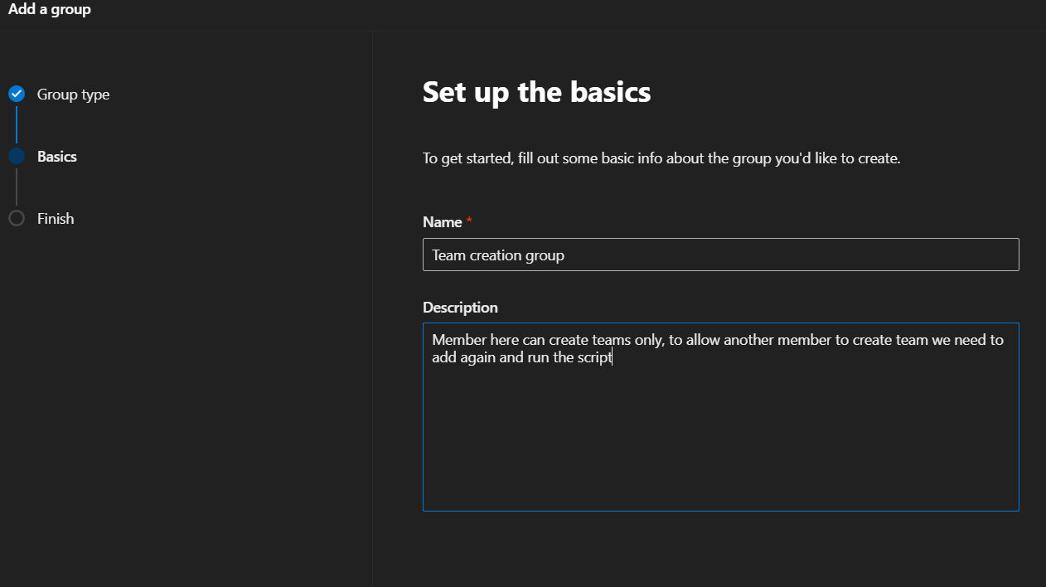

: add team name “something that you another person understand that this is special security group create for allowing to create Teams

1. Add manually

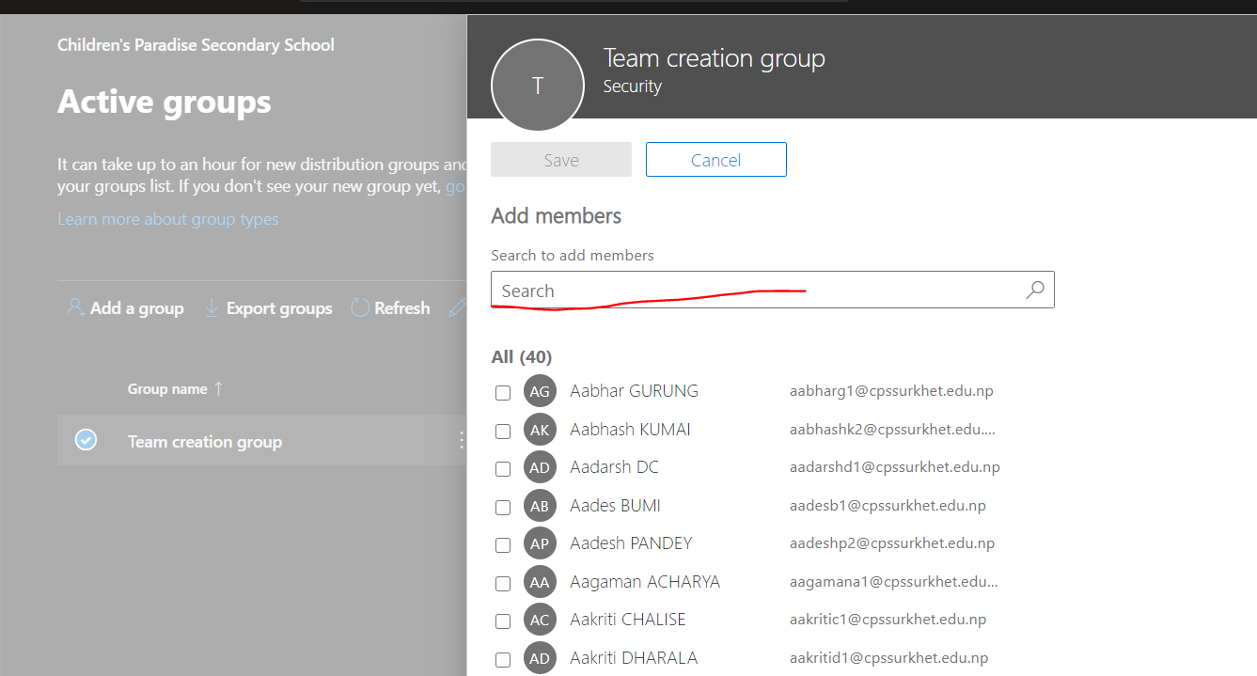

2.Add using powershell

Import-Csv -Path "C:\Users\Surat Adhikari\st.csv" | foreach{Add-TeamUser -GroupId ecc02000-2e28-4ad4-96d2-ea604ce6b78e -Role Member -user $_.email}

3. Run powershell as admin

Connect the powershell

Import-Module SkypeOnlineConnector

$sfbSession = New-CsOnlineSession

Import-PSSession $sfbSession

4.If you have the 2.0 general availability version of the Azure AD PowerShell module (AzureAD) installed, you must uninstall it by running Uninstall-Module AzureAD in your PowerShell session, and then install the preview version by running Install-Module AzureADPreview.

* If you have already installed the preview version, run Install-Module AzureADPreview to make sure it's the latest version of this module.

Copy the script change the *<SecurityGroupName> with you created group name* . Remove<>

And pest script window math and run it ,if all run huncha vayen vane close and open powershell again ani Uninstall-Module AzureAD garera feri install garne Install-Module AzureADPreview.

$GroupName = "<SecurityGroupName>"

$AllowGroupCreation = "False"

Connect-AzureAD

$settingsObjectID = (Get-AzureADDirectorySetting | Where-object -Property Displayname -Value "Group.Unified" -EQ).id

if(!$settingsObjectID)

{

  $template = Get-AzureADDirectorySettingTemplate | Where-object {$_.displayname -eq "group.unified"}

    $settingsCopy = $template.CreateDirectorySetting()

    New-AzureADDirectorySetting -DirectorySetting $settingsCopy

    $settingsObjectID = (Get-AzureADDirectorySetting | Where-object -Property Displayname -Value "Group.Unified" -EQ).id

}

$settingsCopy = Get-AzureADDirectorySetting -Id $settingsObjectID

$settingsCopy["EnableGroupCreation"] = $AllowGroupCreation

if($GroupName)

{

$settingsCopy["GroupCreationAllowedGroupId"] = (Get-AzureADGroup -SearchString $GroupName).objectid

}

 else {

$settingsCopy["GroupCreationAllowedGroupId"] = $GroupName

}

Set-AzureADDirectorySetting -Id $settingsObjectID -DirectorySetting $settingsCopy

(Get-AzureADDirectorySetting -Id $settingsObjectID).Values

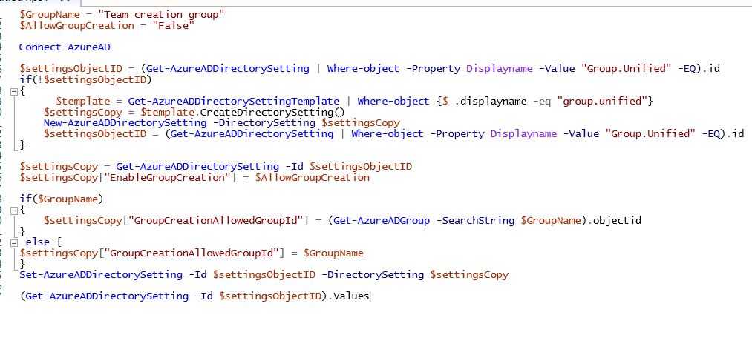

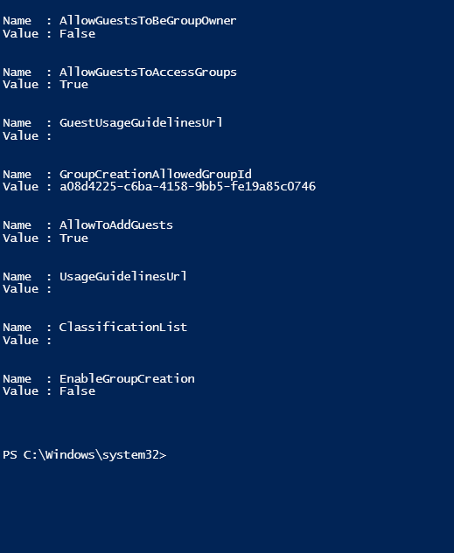

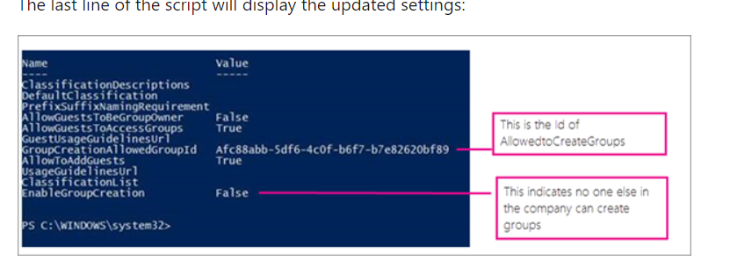

Connection:

Import-Module SkypeOnlineConnector

$userCredential = Get-Credential

$sfbSession = New-CsOnlineSession -Credential $userCredential

Import-PSSession $sfbSession

Security code

$GroupName = "Team creation group"

$AllowGroupCreation = "False"

Connect-AzureAD

$settingsObjectID = (Get-AzureADDirectorySetting | Where-object -Property Displayname -Value "Group.Unified" -EQ).id

if(!$settingsObjectID)

{

  $template = Get-AzureADDirectorySettingTemplate | Where-object {$_.displayname -eq "group.unified"}

    $settingsCopy = $template.CreateDirectorySetting()

    New-AzureADDirectorySetting -DirectorySetting $settingsCopy

    $settingsObjectID = (Get-AzureADDirectorySetting | Where-object -Property Displayname -Value "Group.Unified" -EQ).id

}

$settingsCopy = Get-AzureADDirectorySetting -Id $settingsObjectID

$settingsCopy["EnableGroupCreation"] = $AllowGroupCreation

if($GroupName)

{

$settingsCopy["GroupCreationAllowedGroupId"] = (Get-AzureADGroup -SearchString $GroupName).objectid

}

 else {

$settingsCopy["GroupCreationAllowedGroupId"] = $GroupName

}

Set-AzureADDirectorySetting -Id $settingsObjectID -DirectorySetting $settingsCopy

(Get-AzureADDirectorySetting -Id $settingsObjectID).Values

Pachi kaseilai access dinu cha for team creation vane ,vako security ma add garne ani feri script run garne